**Unit 3 Worksheet 1a**

**Uniform Acceleration**

|  |  |
| --- | --- |
| *t* |  |
| 1. (s) | 1. (cm) |
| 0.0 | 0.0 |
| 1.0 | 5.0 |
| 2.0 | 20.0 |
| 3.0 | 45.0 |
| 4.0 | 80.0 |
| 5.0 | 125.0 |
| 6.0 | 180.0 |

1. In the table at right are position-time data for a wheel rolling down a track.

Plot a position vs. time graph and sketch a smooth curve through the points.

200

175

150

125

100

75

50

25

0 1 2 3 4 5 6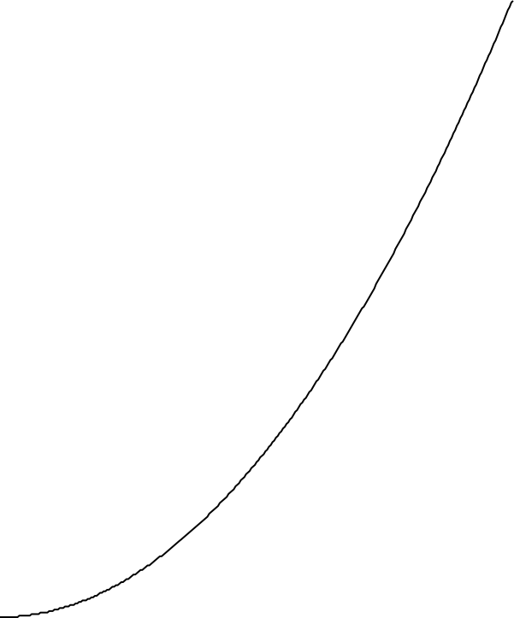

Time (s)

Position (cm)

0 1 2 3 4 5 6

time (s)

2. What is the physical significance of the slope of a position vs. time graph?

3. What is happening to the slope of your position vs. time graph as time goes on?

4. Explain what your answers to questions 2 and 3 tell you about the motion of the wheel.

5. On the position vs. time graph, draw a line which connects the point at *t* = 0 to the point at *t* = 6.0 s.

6. Calculate the slope of this line in the space below. Explain what the slope of this line tells you about the motion of the wheel. Write your explanation in the space to the right of your slope calculation.

|  |  |
| --- | --- |
| Slope Calculation: | Explanation: |

7. On the position vs. time graph, draw a line which connects the point at t = 2.0 s to the point at t = 4.0 s.

8. Calculate the slope of this line in the space below. Explain what the slope of this line tells you about the motion of the wheel. Write your explanation in the space to the right of your slope calculation.

|  |  |
| --- | --- |
| Slope Calculation: | Explanation: |

9. On the position vs. time graph, draw a line tangent to the graph at t = 3.0 s.

10. Calculate the slope of this line in the space below. Explain what the slope of this line tells you about the motion of the wheel. Write your explanation in the space to the right of your slope calculation.

|  |  |
| --- | --- |
| Slope Calculation: | Explanation: |

11. Compare the slopes you have calculated in questions 6, 8, and 10. Summarize the results of your comparison.

12. Consider an object accelerates uniformly. If you were to calculate the average speed of the object for a given interval of time, would the object ever be traveling with an instantaneous speed equal to that average speed? If so, when? Explain!